-- Vehicle Make Name and Model Description are not set as Mandatory
-- Cylinder / Tonnage not set as Mandatory
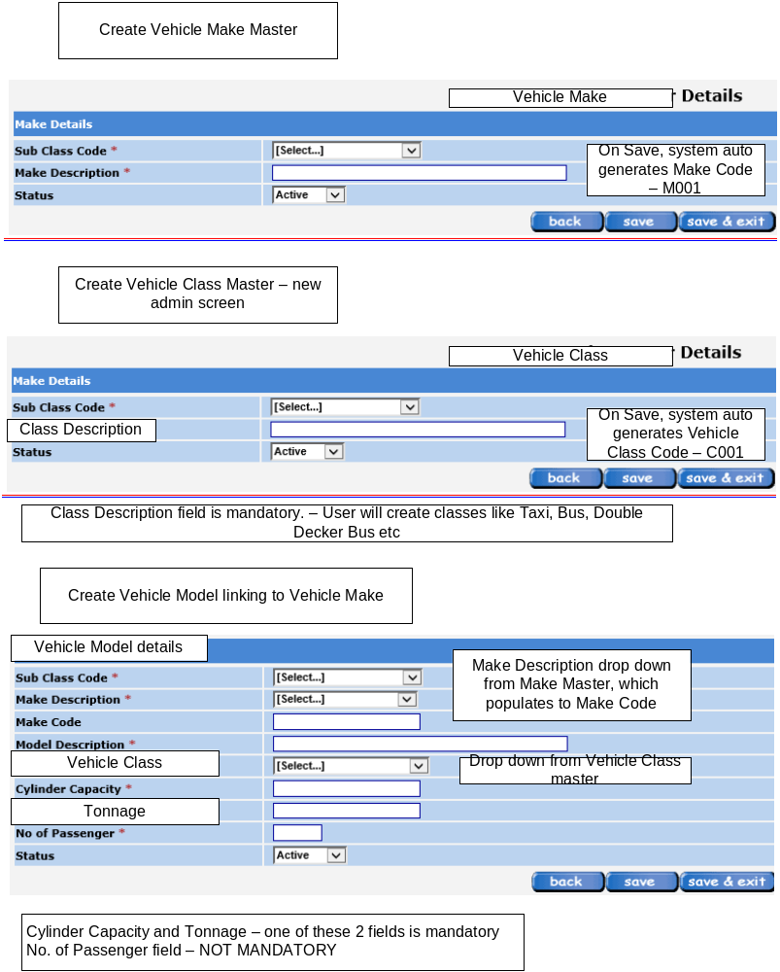

-- Name is more than 150 Chars, NRIC is more than 50 alphanumeric, Contact No. is more than 15
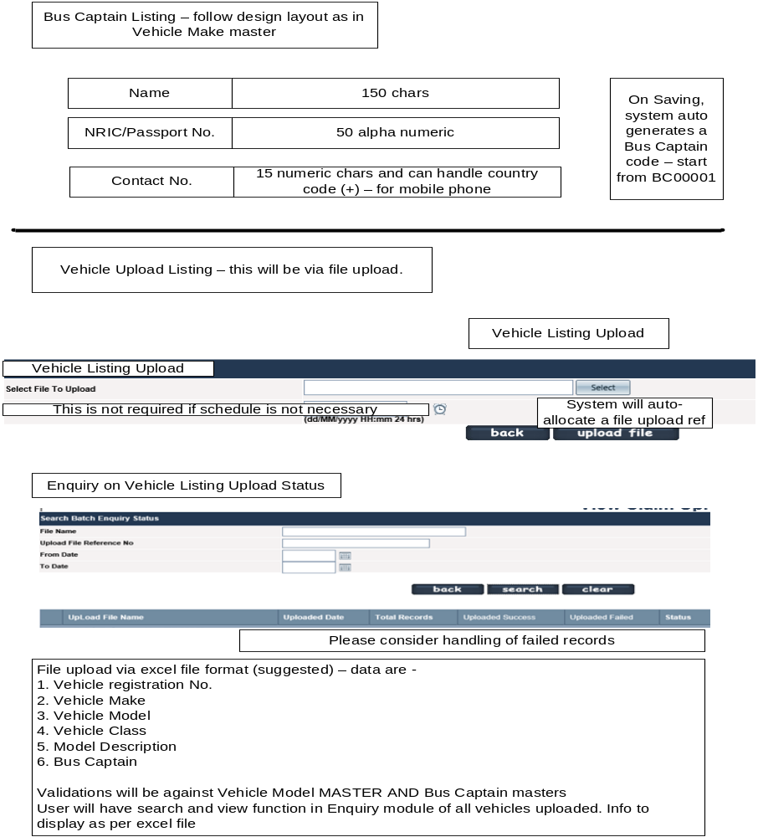

-- Warning Message for Person-In-Charge has no spacing
